DVD PLAYER & HDD RECORDER
DVR2100-HD

User Manual

Please read carefully before operation
Precautions and Functions

Power source
·This DVD&HDD employs AC 90-240V power source, please check local power voltage before operating it.
·If you are not going to use this DVD&HDD for a long period, be sure to disconnect the DVD&HDD from wall outlet.
On safety
·This DVD&HDD is an indoor equipment, to avoid short circuit or electric shock, do not place this DVD&HDD in damp environment.
·Should any solid or liquid enter the cabinet, please immediately cut off the power source, and do not use it until you have had technician check it.
·The DVD&HDD has laser system, to prevent any injury of direct laser radiation, do not attempt to open the cabinet or stare at the laser beam.
·Should any fault occur, please have technician repair it or contact local distributor, do not repair it by yourself.
On placement
·Place the DVD&HDD in a location with adequate ventilation to prevent heat build-up in the DVD&HDD.
·Do not place the DVD&HDD in a location near heat sources like radiator, or in a place subject to direct sunlight, excessive dust, dampness, strong magnetic field or mechanic shake or shock.
On copyright
·Please do not infringe the third party’s copyright when recording TV or DVD/VCD program.

Functions of the DVD&HDD：
·Play and record DVD/VCD/CD/MP3 discs with the program saved in hard disk of the DVD&HDD.
·Built-in tuner allows user to receive and record TV program.
·Record AV or SCART signals output from other equipment (camera, DVD player, etc.)
·Support up to 10 recording tasks.
·Time shifting
·Four recording quality options
·Three video output modes, i.e. compound video, S-Video, SCART.
·Built-in AC-3 decoder, 5.1 channel output, support Dolby.

Playable discs
This DVD&HDD can play the following discs of 8cm or 12cm.
DVD disc.
VCD disc.
CD
MP3
This DVD&HDD can also play additional discs including a majority of DVD-R、DVD-RW、DVD+R、DVD+RW、CD-R、CD-RW video and audio discs.

Any unauthorized change or reconstruction of this product pay cause possible damage to the DVD&HDD thus result in inconvenience to user in operation.

TABLE OF CONTENTS

Installation
Unpacking．．．．．．．．．．．．．．．．．．．．．．．．．．．．．．．．．．．．．．．．．．．．．．．．．．．．．．．．．．．．．．．．．．．．．．．．．．．．．．．．．．．．．1
Connecting with Peripheral Equipment．．．．．．．．．．．．．．．．．．．．．．．．．．．．．．．．．．．．．．．．．．．．．．．．．．．．．．．．．．．．．．2
Rear Panel and Terminals．．．．．．．．．．．．．．．．．．．．．．．．．．．．．．．．．．．．．．．．．．．．．．．．．．．．．．．．．．．．．．．．．．．．．2
Connecting with TV and cable TV (or antenna)．．．．．．．．．．．．．．．．．．．．．．．．．．．．．．．．．．．．．．．．．．．．．．．．．．．2
Using S-Video Terminal to Connect with TV．．．．．．．．．．．．．．．．．．．．．．．．．．．．．．．．．．．．．．．．．．．．．．．．．．．．．3
Using SCART Interface to Connect with TV．．．．．．．．．．．．．．．．．．．．．．．．．．．．．．．．．．．．．．．．．．．．．．．．．．．．．．3
Connecting with Other DVD, VCD, Recorders．．．．．．．．．．．．．．．．．．．．．．．．．．．．．．．．．．．．．．．．．．．．．．．．．．．．3
Connecting with Camera．．．．．．．．．．．．．．．．．．．．．．．．．．．．．．．．．．．．．．．．．．．．．．．．．．．．．．．．．．．．．．．．．．．．．4
Installing Batteries into the Remote．．．．．．．．．．．．．．．．．．．．．．．．．．．．．．．．．．．．．．．．．．．．．．．．．．．．．．．．．．．．．．．．．4
Inserting Power Line．．．．．．．．．．．．．．．．．．．．．．．．．．．．．．．．．．．．．．．．．．．．．．．．．．．．．．．．．．．．．．．．．．．．．．．．．．．．．4
Basic operations
Start-up and shutdown．．．．．．．．．．．．．．．．．．．．．．．．．．．．．．．．．．．．．．．．．．．．．．．．．．．．．．．．．．．．．．．．．．．．．．．．．．．．5
Enjoying TV program．．．．．．．．．．．．．．．．．．．．．．．．．．．．．．．．．．．．．．．．．．．．．．．．．．．．．．．．．．．．．．．．．．．．．．．．．．．．5
Selecting TV System．．．．．．．．．．．．．．．．．．．．．．．．．．．．．．．．．．．．．．．．．．．．．．．．．．．．．．．．．．．．．．．．．．．．．．．．5
Auto Search．．．．．．．．．．．．．．．．．．．．．．．．．．．．．．．．．．．．．．．．．．．．．．．．．．．．．．．．．．．．．．．．．．．．．．．．．．．．．．．5
Selecting TV Channel．．．．．．．．．．．．．．．．．．．．．．．．．．．．．．．．．．．．．．．．．．．．．．．．．．．．．．．．．．．．．．．．．．．．．．．．5
Recording TV Program．．．．．．．．．．．．．．．．．．．．．．．．．．．．．．．．．．．．．．．．．．．．．．．．．．．．．．．．．．．．．．．．．．．．．．．．．．．5
Playing DVD Disc．．．．．．．．．．．．．．．．．．．．．．．．．．．．．．．．．．．．．．．．．．．．．．．．．．．．．．．．．．．．．．．．．．．．．．．．．．．．．．5
Recording DVD Disc．．．．．．．．．．．．．．．．．．．．．．．．．．．．．．．．．．．．．．．．．．．．．．．．．．．．．．．．．．．．．．．．．．．．．．．．．．．．5
Enjoying AV Input Program．．．．．．．．．．．．．．．．．．．．．．．．．．．．．．．．．．．．．．．．．．．．．．．．．．．．．．．．．．．．．．．．．．．．．．．5
Recording AV Input Program．．．．．．．．．．．．．．．．．．．．．．．．．．．．．．．．．．．．．．．．．．．．．．．．．．．．．．．．．．．．．．．．．．．．．．5
Enjoying SCART Input Program．．．．．．．．．．．．．．．．．．．．．．．．．．．．．．．．．．．．．．．．．．．．．．．．．．．．．．．．．．．．．．．．．．．6
Recording SCART Input Program．．．．．．．．．．．．．．．．．．．．．．．．．．．．．．．．．．．．．．．．．．．．．．．．．．．．．．．．．．．．．．．．．．6
Playing Recorded Program．．．．．．．．．．．．．．．．．．．．．．．．．．．．．．．．．．．．．．．．．．．．．．．．．．．．．．．．．．．．．．．．．．．．．．．．6
How to enjoy one channel while recording another channel while watching TV．．．．．．．．．．．．．．．．．．．．．．．．．．．．．．6
Menu
Operations of Menu．．．．．．．．．．．．．．．．．．．．．．．．．．．．．．．．．．．．．．．．．．．．．．．．．．．．．．．．．．．．．．．．．．．．．．．．．．．．．7
Description of Main Menu．．．．．．．．．．．．．．．．．．．．．．．．．．．．．．．．．．．．．．．．．．．．．．．．．．．．．．．．．．．．．．．．．．．．．．．．7
Record Schedule．．．．．．．．．．．．．．．．．．．．．．．．．．．．．．．．．．．．．．．．．．．．．．．．．．．．．．．．．．．．．．．．．．．．．．．．．．．．．．．．7
TV Channel Manager．．．．．．．．．．．．．．．．．．．．．．．．．．．．．．．．．．．．．．．．．．．．．．．．．．．．．．．．．．．．．．．．．．．．．．．．．．．．8
Hard Disk Manager．．．．．．．．．．．．．．．．．．．．．．．．．．．．．．．．．．．．．．．．．．．．．．．．．．．．．．．．．．．．．．．．．．．．．．．．．．．．．．9
System Setup．．．．．．．．．．．．．．．．．．．．．．．．．．．．．．．．．．．．．．．．．．．．．．．．．．．．．．．．．．．．．．．．．．．．．．．．．．．．．．．．．．．9
Tuner type Setup．．．．．．．．．．．．．．．．．．．．．．．．．．．．．．．．．．．．．．．．．．．．．．．．．．．．．．．．．．．．．．．．．．．．．．．．．．．．9
Auto Overlay．．．．．．．．．．．．．．．．．．．．．．．．．．．．．．．．．．．．．．．．．．．．．．．．．．．．．．．．．．．．．．．．．．．．．．．．．．．．．10
Date/Time Setup．．．．．．．．．．．．．．．．．．．．．．．．．．．．．．．．．．．．．．．．．．．．．．．．．．．．．．．．．．．．．．．．．．．．．．．．．．．10
Record Quality．．．．．．．．．．．．．．．．．．．．．．．．．．．．．．．．．．．．．．．．．．．．．．．．．．．．．．．．．．．．．．．．．．．．．．．．．．．．10
Time Shifting Setup．．．．．．．．．．．．．．．．．．．．．．．．．．．．．．．．．．．．．．．．．．．．．．．．．．．．．．．．．．．．．．．．．．．．．．．．．10
DVD Player Setup ．．．．．．．．．．．．．．．．．．．．．．．．．．．．．．．．．．．．．．．．．．．．．．．．．．．．．．．．．．．．．．．．．．．．．．．．11
Auto Record File Length．．．．．．．．．．．．．．．．．．．．．．．．．．．．．．．．．．．．．．．．．．．．．．．．．．．．．．．．．．．．．．．．．．．11
OSD Language Setup ．．．．．．．．．．．．．．．．．．．．．．．．．．．．．．．．．．．．．．．．．．．．．．．．．．．．．．．．．．．．．．．．．．．．．．．．．．11
Default Setup．．．．．．．．．．．．．．．．．．．．．．．．．．．．．．．．．．．．．．．．．．．．．．．．．．．．．．．．．．．．．．．．．．．．．．．．．．．．．．．．．．11
Version Number．．．．．．．．．．．．．．．．．．．．．．．．．．．．．．．．．．．．．．．．．．．．．．．．．．．．．．．．．．．．．．．．．．．．．．．．．．．．．．．11
Senior Operations
Operations of DVD ．．．．．．．．．．．．．．．．．．．．．．．．．．．．．．．．．．．．．．．．．．．．．．．．．．．．．．．．．．．．．．．．．．．．．．．．．．．．12
Operations of Recorded Program．．．．．．．．．．．．．．．．．．．．．．．．．．．．．．．．．．．．．．．．．．．．．．．．．．．．．．．．．．．．．．．．．．12
Other Instructions
On Frontal Panel．．．．．．．．．．．．．．．．．．．．．．．．．．．．．．．．．．．．．．．．．．．．．．．．．．．．．．．．．．．．．．．．．．．．．．．．．．．．．．．14
On Remote Controller．．．．．．．．．．．．．．．．．．．．．．．．．．．．．．．．．．．．．．．．．．．．．．．．．．．．．．．．．．．．．．．．．．．．．．．．．．．16
Troubleshooting．．．．．．．．．．．．．．．．．．．．．．．．．．．．．．．．．．．．．．．．．．．．．．．．．．．．．．．．．．．．．．．．．．．．．．．．．．．．．．．17
Specifications．．．．．．．．．．．．．．．．．．．．．．．．．．．．．．．．．．．．．．．．．．．．．．．．．．．．．．．．．．．．．．．．．．．．．．．．．．．．．．．．．18

Installation

Installation
Unpacking: please unpack this product and check whether you have received the following items.
A DVD & HDD Recorder and Player
A remote controller | A pair of batteries | An audio and video cable
A power cord | A user’s manual
After checking that you have received all the above items, connect the DVD&HDD with peripheral equipment following the instructions below:

Installation

Connecting Peripheral Equipment
Rear Panel and Terminals
The output and input interfaces of power cord are in the rear of the DVD&HDD, through these interfaces this DVD&HDD can be connected with TV/monitor, camera, power amplifier, etc., see the figure below:

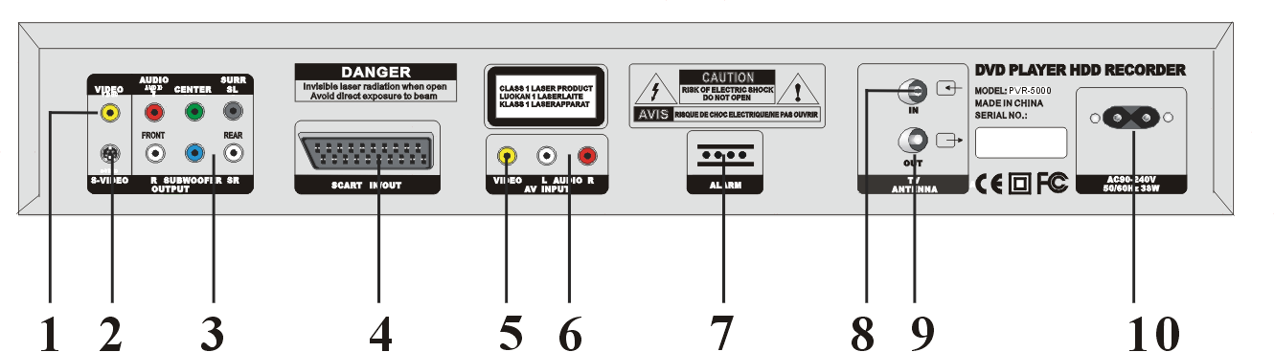
Notes to parts of rear panel:
- Compound video output: to connect with TV and output compound video signals.
- S-VIDEO output: to output video signal to TV, it is clearer than compound video signal.
- 5.1 CH audio output: it supports DOLBY and can be connected with up to 6 speakers.
- SCART interface: to connect with equipment with SCART interface, for European use only.
- Video input: compound video signal input, to receive the video signals input from other equipment.
- Audio input L/R: L/R stereo channel, to receive the video signals input from other equipment.
- Alarm.
- TV signal input: to receive cable TV signal.
- TV signal output: to connect with TV, you can watch TV without powering on this DVD&HDD using it.
- Power cord plug: to connect with AC power source.

Connecting with TV and cable TV (or antenna)
This DVD&HDD provides built-in tuner, cable TV signal can directly enter this DVD&HDD, additionally, to enable user to independently receive TV program, this DVD&HDD is furnished with a TV signal output jack, see the connection figure below:

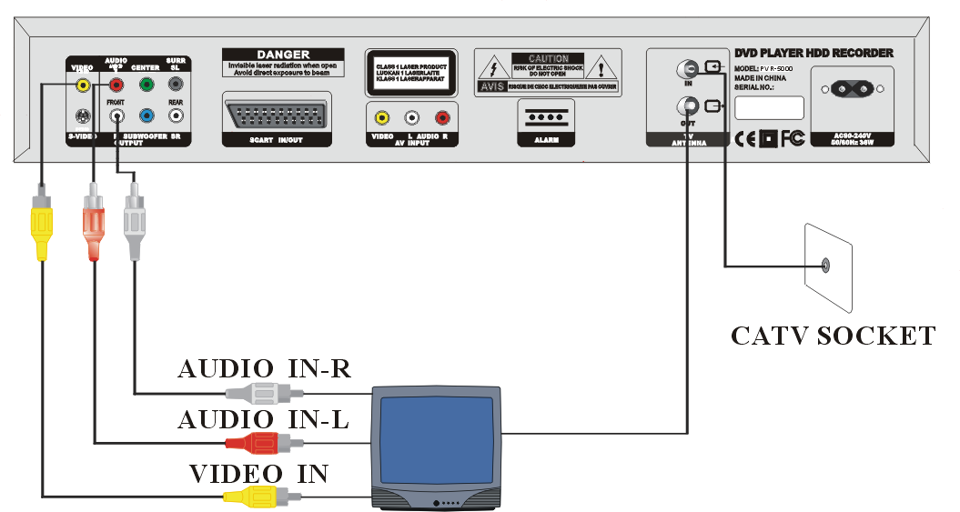

Actually the built-in tuner of this DVD&HDD serves as a receiving circuit of TV, so,
·If this DVD&HDD is connected with monitor instead of TV, the user can also receive TV program via this DVD&HDD.
·TV program timing recording is regardless of power switch of TV, whether it is powered on or off, as long as you have set timing recording task, even though TV is powered off, the DVD&HDD can normally record the scheduled TV program.
Installation

Using S-Video Terminal to Connect with TV
If TV has S-VIDEO input jack, it is recommended to connect it with S-VIDEO output of this DVD&HDD so as to realize video effect of high definition, see the connection figure below:

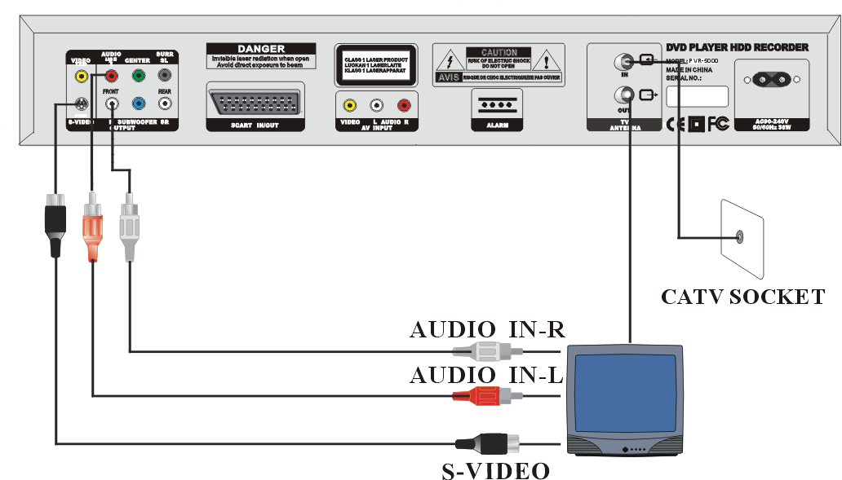

Using SCART Interface to Connect with TV (for European use only)
See the connections of this DVD&HDD with TV with SCART interface in the figure below:

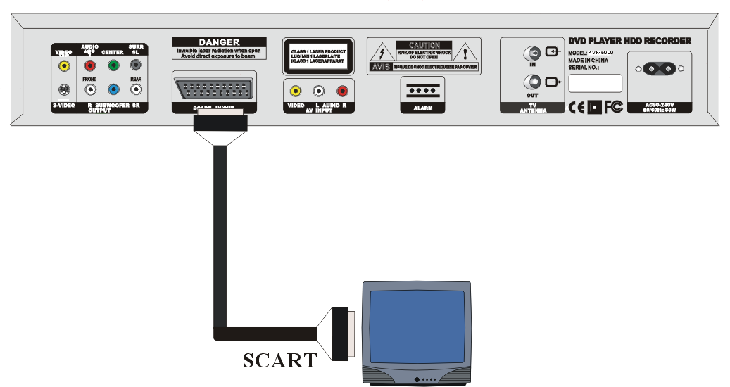

Connecting with other DVD, VCD, Recorder
By connecting AV input with AV output of other equipment user can record the audio signal output from other equipment (DVD, VCD player), see the connection figure below:
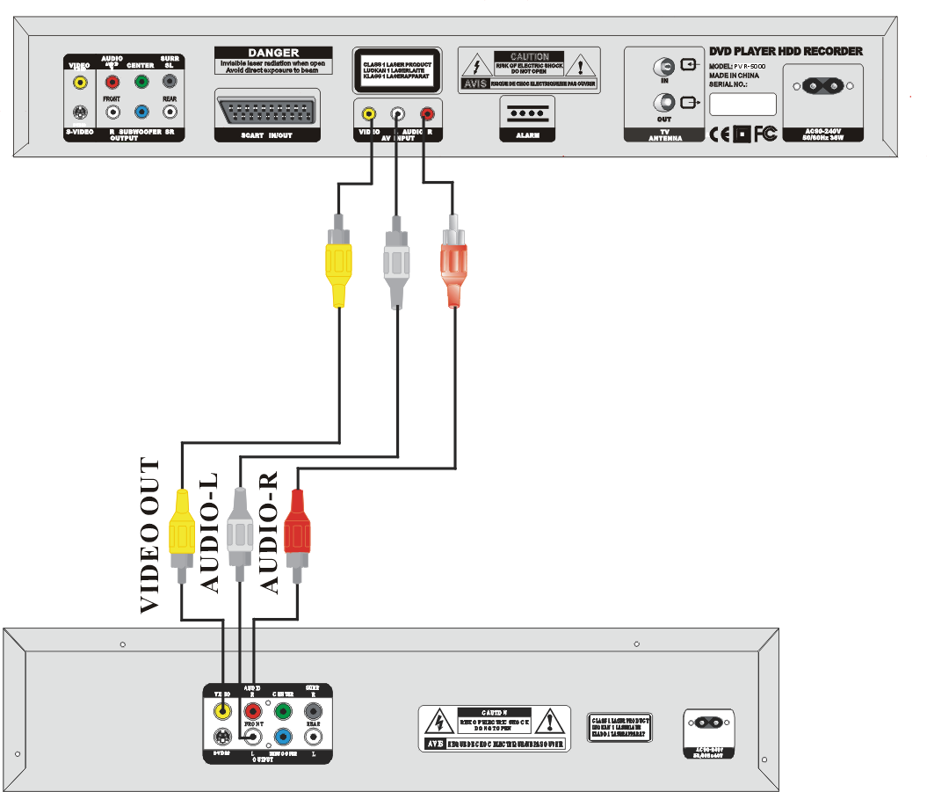

Installation

Connecting with camera
This DVD&HDD can display or record the images captured in camera. If the camera has built-in microphone, user can connect audio interface of camera to the DVD&HDD to record audio signals. If the camera has no microphone, user can connect an additional microphone to the DVD&HDD. This DVD&HDD records audio and video signals synchronously. See the connection figure below:
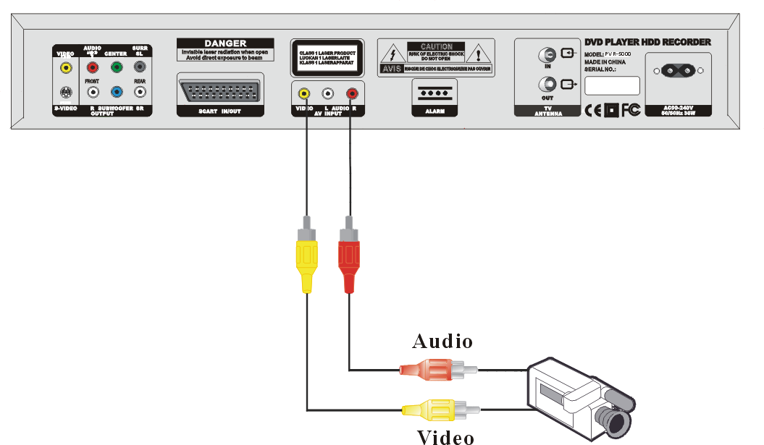
Installing Batteries into the Remote
This DVD&HDD is mainly operated via remote controller, before operating it open the rear cover of the remote controller and insert the batteries following the instructions below, then please close the rear cover.

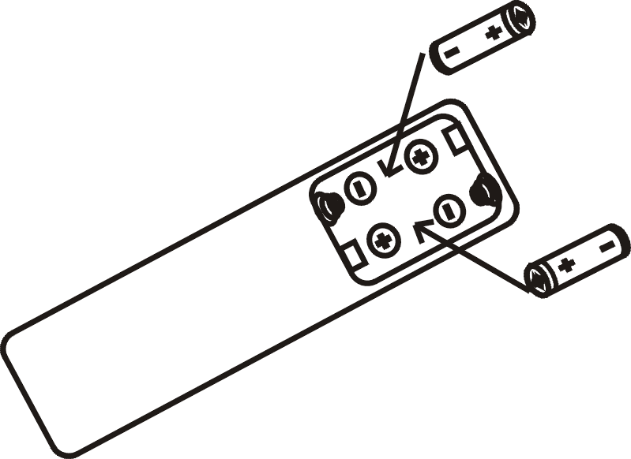

Inserting Power Line
After all connections with peripheral equipment are completed and identified well, insert one end of the supplied power line into the power jack in the rear of this DVD&HDD, insert the other end into wall outlet.

Basic Operations

Basic Operations
Start-up
- Make sure that you have obeyed all precautions as above prescribed.
- Check whether this DVD&HDD is properly connected with peripheral equipment, if power source has been connected, check whether the red indicator in the panel is on.
- If everything above said is ok, power on peripheral equipment first, set TV into AV mode.
- Press button in panel or remote controller, the red indicator in the panel turns off, TV screen displays the start-up picture of this DVD&HDD.

Shut down
- Press button in panel or remote controller, when the red indicator in the panel turns on, power off peripheral equipment.
- Do not shut down the DVD&HDD while playing disc, recorded program or recording program.

Enjoying TV program
- Tuner Type Setup
Press “SETUP” button in the remote controller to enter menu, press “▼” to move light bar to the item “SYSTEM SETUP”, then press “ENTER”, move light bar to the item “TUNER TYPE SETUP”, press “ENTER”, move the light bar to required TV system, press “ENTER” to confirm (the DVD&HDD has been set tuner type, generally it doesn’t need to change).
- Automatic Search
Press “SETUP” button to enter menu, press “▼” to move light bar to the item “TV CHANNEL MANAGER”, press “ENTER”, move light bar to the item “AUTO”, press “ENTER” to activate “AUTO”. Press “RETURN” to terminate “AUTO”.
- Selecting TV Channel
Press “TV/AV” to shift in loop between TV, AV and SCART signal input, every time the shift proceeds, corresponding input state will be displayed in the right bottom of the screen.
Press “CH+”and“CH-”buttons in the remote controller to shift between current channel and the two neighboring channels. While in TV mode, user can directly press the number buttons in remote controller to select desired channel, if the channel No. is a two-digit figure, please first press “- -”,then enter the two digits.
Recording TV Program
- While enjoying TV program press “REC” button in the remote controller to start recording, TV screen display the indication words “RECORD”, press “STOP” to stop recording.

Playing DVD Disc
- Loading in disc: press “EJECT” button in the remote controller to open the tray, place a DVD disc in the tray then press “EJECT” button once again, the DVD&HDD start playing DVD disc, press “STOP” button to stop playing.
- DVD playback: if there is already disc in the DVD&HDD, press “DVD” button in the remote controller to play DVD.
Recording DVD Disc
- While enjoying DVD program press “REC” button in the remote controller to start recording DVD program, press “STOP” button to stop recording.

Enjoying AV Input Program
- Press “TV/AV” in the remote controller to shift into AV mode, TV will display the video program input via AV interface.
- The DVD&HDD can input video program via AV interface from camera or other DVD player.
Recording AV Input Program
- In AV mode, press “REC” button in the remote controller to start recording program, press “STOP” button to stop recording.

Basic Operations

Enjoying SCART Input Program (for European use only)
- Press “TV/AV” in the remote controller to shift into SCART mode, TV will display the video program input via SCART interface.
- The video program input via SCART interface comes from SCART output of other equipment such as TV, DVD player with SCART interface.
Recording SCART Input Program
- In SCART mode, press “REC” button in the remote controller to start recording program, press “STOP” button to stop recording.

Playing Recorded Program
In TV/AV/SCART mode, press “PROG” or “PLAY”in remote controller, the screen will display the list of recorded program, move the light bar to desired program, press “PLAY” to play.

How to enjoy one channel while recording another channel while watching TV
This player has built-in satellite receiver and thus can independently receive TV programs without any impact on TV’s receiving effect, so does TV to the player. When external TV signals are connected via TV cable to satellite receiver input of the player, then connected to TV from the satellite receiver output, then you can enjoy one channel and record another channel at the same time, please operate following the instructions below:
Power on the machine and skip to the channel you want to record, then press TV/AV button in TV set to switch into TV state, you can then see one channel with TV’s instinctive receiving capability while recording another button at the same time.

Remarks
- To display or clear the information of current operating state, press “DISPLAY” button in the screen.
- If “” appears in TV screen when pressing buttons in remote controller, it means that the function is not available in current state.
Operating Menu

Operating Menu
Many functions are commanded and many parameters are set through the menu.
To enter the menu interface, press “SETUP” button in the remote controller while in DVD playing modes.
Operations of Menu
To move between the different items in menu, press “▲”or“▼” in remote controller.
When the item to be selected is figure or when you select items in horizontal direction (e.g. year, month, date, second), press “◄” or “►”, then the light bar will move leftward or rightward.
To modify letters or figures, press “CH+” or “CH-” button.
When the settings of a menu have been completed, press “ENTER” to save current settings or enter information, if you want to cancel the operation while in entering or selecting operations and to return to previous menu, press “RETURN”.
For each item there is a status bar in the bottom of window to define the item.
Description of Main Menu
Press “SETUP” to enter “SETUP MENU”
SETUP MENU --- HOME PAGE

RECORD SCHEDULE
TV CHANNEL MANAGER
HARD DISK MANAGER
SYSTEM SETUP
OSD LANGUAGE SETUP
DEFAULT SETUP
VERSION NUMBER

Record Schedule
This DVD&HDD supports up to 10 timing recording tasks, it can realize timing recording of TV program, AV, SCART input signals. Move the light bar to the item “RECORD SCHEDULE”, press “ENTER”, the screen will display timing tasks 01-10, select one task and press “ENTER” to enter the menu items “EDIT”, “DEL”, “EXIT”. When the light bar moves to the item “EDIT”, press “ENTER” to show the menu below:
2002/05/02 07:38:35 THURSDAY

START TIME:2002/05/02 07:38
END TIME:07:38
SOURCE:CH001
PROG NAME:CH010738
TYPE:ONE TIME/EVERY DAY/EVERY WEEK
REC-Q:SEP/EP/LP/SP

OK CANCEL

Modifying timing recording task:
Starting time: the time to start recording
End time: the time to stop recording
Source: in timing recording optional three signal sources TV, AV, SCART can be recorded. To set channel No. of TV program, user can directly press number button, while to set the signal source as AV or SCART, user can press “CH+” or “CH-”.

Operating Menu

Prog name: give a name to timing recording program.
Type: “ONE TIME” indicates recording for only one time, this task will automatically be deleted after the task is over. “EVERY DAY” indicates the recording will start from the set starting time every day. “EVERY WEEK” indicates the recording will start from the set starting time on the first set day every week, for example, if recording times in the selected as “EVERY WEEK” in the above menu, the recording will start from 7:38 am every Thursday.
Recording quality: the quality of timing recording has four levels, i.e. SEP、EP、LP、SP.

Deleting Timing Recording Task: when the screen displays ten timing tasks 01-10, select the task to be deleted and press ENTER to enter the menu items “EDIT”, “DEL”, “EXIT”. When the light bar moves to the item “DEL”, press “ENTER” to delete the task:
Notes:
As timing task is closely related to time, before using this function, make sure the systemic date and time is correct.
When recording TV program, TV program can still be recorded normally even with TV powering off.
Timing recording function will work if this DVD&HDD is turn off.

TV Channel Manager
It works to manage TV channel, when the light bar moves to “TV CHANNEL MANAGER”, the screen will display the menu below:
AUTO
MANUAL
FINE
ADD CHANNEL
DEL CHANNEL
SKIP ON
SKIP OFF
TV CHANNEL MANAGER

When the light bar moves to “AUTO”, press “ENTER” to start automatic search, while in automatic search, user can press “RETURN” to terminate the search.
When the light bar moves to “MANUAL”, press “ENTER” to manually change current channel, press “►” to search the channel after current channel, press “◄” to search the channel before current channel, press “ENTER” to save the search results. “MANUAL” allows user to distribute defined channel No. to a popular TV channel as per his preferences.
When the light bar moves to “FINE”, press “ENTER” then press “►” and“◄” to make fine tuning over current channel.
Add channel: generally each channel to be searched by this player has only channel No., while a channel to be searched by TV may be allocated multi channel No., as a result, the No. of this player’s channel may not be the same with that of respective channels in TV set, this feature enables the player’s channel No. become conformed to TV set’s, you can operate following the instructions below:
Compare this player’s channel No. and TV’s from channel 0 or 1, if they are the same, skip to compare next ones, if any different channel is found, for example channel 5, press “SETUP” to show up operating menu, select “TV channel manager”, then select “Add channel”, press “Enter”, channel 6 corresponding to channel 5 will be added, then number of the former channel 6 and the next channels will automatically plus 1, by “manual searching” and fine tuning, you can enable the existing channel 5 conformed to the respective channel in TV till all the two players’ respective channels are completely conformed.
Del channel: to delete a channel you don’t like, while the player is playing the channel, press SETUP to show up menu, select “TV channel manager”, then select “Delete channel”, press “Enter”, the current channel is deleted, the number of all the next channels will automatically minus 1.
Skip on: to hide current channel (for example channel 9), select “Hide channel” in menu, then press “Enter”, channel 9 is hidden, after that operation, when you press “CH+” at channel 8, the player will skip to channel 10 instead of channel 9.
Skip off: even if a channel is hidden, but if we press number button, the hidden channel still can show up, if you want to resume the channel, press SETUP to show up menu and select “Resume channel”, by pressing “Enter” the hidden channel will be resumed.

Operating Menu

Hard Disk Manager
It works to manage hard disk, when light bar moves to this item, press “ENTER”, the screen will display the menu below:
HARD DISK MANAGER
SYSTEM INFO
SCAN DISK
FORMAT DISK

System Info: it includes total hard disk space, remaining hard disk space, remaining hard disk time and available recording time for SEP/EP/LP/SP four recording quality.
When the light bar moves to “SYSTEM INFO”, press “ENTER”, the screen will show the menu below:
SYSTEM INFO PAGE
TOTAL DISK SPACE — — 40，044MB
FREE DISK SPACE — — 40，044MB
FREE RECORDING TIME:
SEP — — 81H:29M:22S
EP — — 33H:03M:21S
LP — — 16H:37M:36S
SP — — 08H:32M:35S

Scan Disk: if you have operated this DVD&HDD for a long time, repetitive reading and writing of hard disk may result in slow-moving pictures even halt, but it does not mean the hard disk has been damaged, user can recondition the hard disk by scanning it.
Format Disk: format hard disk, press “ENTER” to display a picture to confirm, press “ENTER” to format the hard disk of the DVD&HDD.
Notes: once the hard disk is formatted, all programs in the hard disk will be lost and can not be recovered.

System Setup
Function list of system setup
SYSTEM SETUP PAGE

TUNER TYPE SETUP
AUTO OVERLAY
DATE/TIME SETUP
RECORD QUALITY
TIMESHIFTING SETUP
DVD PLAYER SETUP
AUTO RECORD FILE LENGTH

Tuner Type Setup
TUNER TYPE SETUP
PAL DK
PAL B/L
SECAM L
SECAM LS

Operating Menu

Select TV receiving system, for different countries TV system is different, this DVD&HDD has been preset TV system according to real condition of destination, but user can modify it.

Auto Overlay
AUTO OVERLAY
ENABLE
DISABLE

Hard disk has only limited space, if necessary user needs to delete existing recorded program for new recording task. If the DVD&HDD is set “AUTO OVERLAY”, the newly recorded program will automatically overwrite the existing program (other than locked program), if the user select “DISABLE”, the DVD&HDD will indicate “DISK IS FULL” when hard disk space run out, if you does not clean part or all of existing programs, you can not continue recording.

Date/Time Setup
DATE: 2002 / 05 / 03
TIME: 05 :16 :07
DATE/TIME SETUP

To set the date and time of the DVD&HDD, user can press “▲、▼、◄、►”buttons to move cursor, directly press number buttons to modify the items, press “ENTER” to save the setting, the time of timing recording will be based on the setting.

Record Quality
RECORD QUALITY
SEP
EP
LP
SP

SEP/EP/LP/SP represents four levels of recording quality in quality increasing sequence, press “▲”or“▼” to move the light bar to desired option, press “ENTER” to confirm.
As hard disk has only limited space, the higher the recording quality is, the shorter available recording time is, user can set the recording quality and time to his specific requirements.

Timeshifting Setup
Select maximum time shifting length.
TIMESHIFTING SETUP
30 MINUTE
60 MINUTE
90 MINUTE
120 MINUTE

Applications of Time Shifting TV: If you have to handle of some important business while enjoying a pleasant program, press “T/SHIFT” button in the remote controller to record the program, when you return from the business, press “FR” to playback from when you miss the program, if you don’t like advertising or
Operating Menu

any part of the program, you can press “FF” to catch up the broadcasting program step by step, it seems like the time is shifting exclusively for a specific user. Unlike recording program, time shifting program is not saved in hard disk, it will no more exist when the DVD&HDD is powered off or shutdown.

DVD Player Setup
DVDPLAYER PAGE
ANALOG AUDIO OUTPUT
DIGITAL AUDIO OUTPUT
VIDEO SYSTEM
SCREEN ASPECT
RETURN HOMEPAGE
2 CHANNEL
5.1 CHANNEL

Analog Audio Output: select stereo or 5.1 CH output.
Digital Audio Output: select DOLBY or LPCM output.
Video System:NTSC or PAL when playing DVD disc, the system shall be conformed to system of disc program, if the caption in screen is found shaking, user can select the other system.
Screen Aspect: video output aspect ratio, 16:9 wide screen, 4:3 panorama, 4:3 letter box, it should be supported by DVD disc.

Auto Record File Length

AUTO RECORD FILE LENGTH
BY TIME
BY SIZE

Auto Record File Length: user can set the length of automatically recorded program in hours or Mbyte.

OSD Language Setup
User can set the language of menu interface language using this function, or press “LANGUAGE” button in the remote controller to shift between different languages.
OSD LANGUAGE SETUP
ENGLISH
CHINESE

Default Setup
Default Setup is the standard setting upon testing at factory, it is known as default setting, it is the basis for various setting. User can make setting to real condition and specific requirements. In the event the DVD&HDD is disorderly set or does not realize expected effects, user can select “Default Setup” then readjust the DVD&HDD.

Version Number
It shows the version information, when reporting faults to our company by phone or email, user must tell such information.

Senior Operations

Senior Operations
Operations of DVD
- See the basic operations of DVD in page 5.
- Selecting DVD Menu: when starting playing DVD, screen will display the title menu, press “▲”、“▼”、“◄”、“►” in the remote controller to select, and press “ENTER” to confirm.
- FF (Fast Forward), FR (Fast Backward): press “FF” or “FR” to fast forward or fast backward, every time you press the buttons, the speed to fast forward or fast backward will change, the DVD&HDD provides three 2x,4x,8x speed for your option. Press “PLAY” to resume playing at normal speed..
- Previous section/Next section: generally DVD is stored in sections, press “PREV” or “NEXT” to skip to previous/next section.
- PAUSE: press “STEP/PAUSE” to pause playing, press it once again to play step by step, press “PLAY” to resume playing normally.
- Caption selection: first press “SUB-T”, TV screen will display the following menu in its left top.
01/09
EN/OFF
A

It indicates there are total 9 caption options and the DVD&HDD is using caption form 1. Press “◄”、“►”to select the item to be changed, press “ENTER” to execute the change, a few seconds after the selection the picture will disappear automatically.
- Selecting dub: first press “R/L” button, TV screen will display the menu below in the left top.
1/3 DB
EN 5.1CH OFF


It indicates there are total 3 dub options and the DVD&HDD is using dub form 1. Press “◄”、“►”to select the item to be changed, press “ENTER” to execute the change
- GOTO: press “GOTO” button in the remote controller, the screen displays chapter No. and time in the left top, press “▲”、“▼”、“◄”、“►” to move cursor between the items to be set, press number button to change the chapter No., press “ENTER” to confirm.
- Returning to Title Menu: press “TITLE” to return to the title menu of DVD, reselect section and play.
Operations of Recorded Program
Press “PROG” or“PLAY”to access the already recorded program.
PROGRAM LIST
PVR 2002/ 05/ 05 – 12 :30
PVR 2002/ 05/ 04 – 12 :38
PVR 2002/ 05/ 03 – 19 :58
PVR 2002/ 05/ 02 – 00 :21
PVR 2002/ 05/ 02 – 03 :26

INFO
DATE: 2002/ 05/ 05
TIME: 12 :30 :11
LGTH: 00 :02 :08
TYPE: PROGTYPE
MODE: LP

Press “▲”、“▼” to move the light bar to desired program, press “ENTER” to display the operating items of current program as below:
Senior Operations

PROGRAM LIST
PVR 2002/ 05/ 05 – 12 :30
PVR 2002/ 05/ 04 – 12 :38
PVR 2002/ 05/ 03 – 19 :58
PVR 2002/ 05/ 02 – 00 :21
PVR 2002/ 05/ 02 – 03 :26

PLAY
SELECT
LOCK
RENAME
DELETE
PLAY LIST

Press “▲”、“▼” to move light bar to desired operating items, press “ENTER ” to execute the operation.
Playing: press “ENTER” or “PLAY” to playback the program, press “STOP” to stop playing it.

Locking: press “ENTER” to lock a popular program, use will not be able to delete the program unless he press “ENTER” once again to unlock the program, and the locked program can not be automatically overwritten.
Renaming: press “ENTER” to rename program, screen will display the menu below:

RENAME
PROGRAM NAME：
PVR 2002/ 05/ 05 — 12 ：30
TYPE：PROGTYPE
KEYBOARD：

A B C D E F G H I J K L M N O P Q R
S T U V W X Y Z ：_ ，— / 0 1 2 3 4 5
6 7 8 9 ↑ ↓ ← → OK

There are small light bars in the above keyboard box, press “▲”、“▼”、“◄”、“►” to move the small the desired letter then press “ENTER” to select it. Move the small light bar to “↑、↓” in the keyboard box, select them to shift between the items “PROGRAM NAME” and “TYPE”, after the operation is completed, move the light bar to “OK”, press “ENTER” to save it.
Deleting: press “ENTER” to confirm, then the screen will display the menu below:

DELETE PROGRAM

PRESS ENTER KEY TO CONFIRM
PRESS RETURN KEY TO CANCEL

User can press “ENTER” once again to delete current programs.
Playlist: press the item “SELECT” to check the desired program and place them all into playlist, these programmed can be played continuously.
Other Instructions

Other Instructions

On Frontal Panel
See the front view in the figure below:

In the central top is DVD tray door, below are displays of various status information, in the left is power button, in the left is function buttons area.
As this player has so wide range of functions, most of which need to be realized with remote controller, nevertheless, in the right panel there are 8 buttons, each has different functions for respective modes, so as to ensure proper operation of the player even if remote controller is unavailable.
Here below describes the functions of the 8 buttons in 5 different modes, the characters in “[ ]” represent the button name of corresponding remote controller in the same mode.
1. In DVD playing mode
[PREV]

[ FR ] [PLAY] [ FF ]

[EJECT] [STOP] [NEXT] [L/R]

While playing DVD, press these buttons to open/close DVD tray, play, stop, fast forward, fast reverse, skip to previous/next segment, select sound channel.

2. In TV mode
[TV/AV]

[CH -] [PLAY ] [CH +]

[EJECT] [STOP/RETURN] [TV/AV] [REC]

While watching TV via the player, press these buttons to open/close DVD tray, play recorded program, stop playing recorded programs, switch between TV/AV/SCART states, change TV channels, record TV programs.

3. In AV/SCART mode
[TV/AV]

[SETUP] [PLAY ] [SETUP]

[EJECT] [STOP/RETURN] [TV/AV] [REC]

While in AV/SCART input state, press these buttons to open/close DVD tray, play recorded program, stop playing recorded program, switch between TV/AV/SCART, conduct system setting, record the input audio and video signals in current state.

Other Instructions

4. In PLAY mode
[ ▲ ]

[ FR ] [PLAY] [ FF ]

[EJECT] [STOP/RETURN] [ ▼ ] [REC]

While playing recorded programs, press these buttons to open/close DVD tray, play recorded programs, stop playing recorded programs, fast forward, fast reverse, move icon bar upward and downward, record the input audio and video signals in current state.

5、In SETUP mode
[ ▲ ]

[ ◄ ] [ENTER] [ ► ]

[EJECT] [RETURN] [ ▼ ] [REC]

While performing system setting, press these buttons to open/close DVD tray, return to main menu, move icon bar upward, downward, leftward, rightward to select and confirm, record the input audio and video signals in current state.
In the above said modes, while recording or playing recorded programs, “EJECT” and“REC” button can not work.

Other Instructions

On Remote Controller

- POWER: to power on or off the DVD&HDD.
- EJECT: To open or close tray.
3、 TITLE: To return to root directory of DVD.
4、 REPEAT: To activate or deactivate repeat playing function.
5、 DIGEST: To scan the program.
6、 PROG: To play program in programmable order or show the recorded program list.
7、 SUB-T: To select the caption of different languages for DVD disc.
8、 A-B: To repeat a defined section.
9、 ANGLE: To select view angle.
10、CHAPTER: To select a chapter.
11、GOTO: While playing DVD press the button to skip to defined chapter.
12、PBC: To activate or deactivate PBC function.
13、P/N: To shift between TV systems PAL/NTSC.
14、CLEAR: To clear DVD operating display picture.
15、AUDIO: To select a channel.
16、MUTE: To silence
17、BOOKMARK: To add bookmark to current section
18、R/L: To select channel mode
19、Number buttons: To select TV channel or enter number.
20、CH+/CH-:To select TV channel.
21、REC: To record current video.
22、TV/AV: To select video input.
- DVD: To play DVD disk.
- T/SHIFT: Time shifting.
25、DISPLAY: To display or clear operating information.
26、SETUP: To set menu
27、▲▼◄►: Buttons to move light bar
28、ENTER: To select or confirm
29、RETURN: To return
30、FUNC: Function button
31、Playing operating buttons: to realize various playing operations over DVD or recorded program
32、ZOOM: To zoom in or zoom out images
33、LANGUAGE: To select menu language.
34、VOL+/VOL-: To turn up or turn down volume.
Installing batteries into the remote controller: please install the supplied two batteries 7# as per the polarity mark on the battery cartridge.
Direction and distance: when operating remote controller, please point it at IR receiver of frontal panel of this DVD&HDD at an angle within range of ±30º and at a distance within 8m.
Precautions: do not drop the remote controller or make it subject to dampness. Do not expose the IR receiver in frontal panel in sunlight or any strong light.
When batteries run out, please timely replace them, do not use new and old batteries together, do not use rechargeable batteries.

Other Instructions

Trouble shooting

Description of Trouble | Possible Reasons | Solutions
No sound after changing channel | Malfunction caused by other disturbance | Turn off the power and restart it.
No power | Power cord is not properly plugged. | Plug the power cord firmly.
Remote controller can not work | Batteries run out.  Remote controller does not point at IR remote controller of DVR. | Replace with new batteries.  Point remote controller at IR receiver.
No image in TV screen | Video cable is disconnected or not properly connected.  TV is still in TV mode. | Connect it as per connection figure  Switch TV in AV mode.
The DVD&HDD can not play. | You have used incompatible disc.  You have placed the disc in the tray upsidedown. | Use a disc compatible to this DVD&HDD.  Place the disc again with label side upward.
No sound in speaker | Audio cable is disconnected or not properly connected.  Audio initial functions are wrongly set.  Operation error occurs in peripheral amplifier. | Connect it as per connection figure.  Reset it.  Properly operate amplifier.
Discontinuous sound and image distortion | You have used dirty disc.  You have used a scratched/frizzled disc. | Clean the disc with clean soft cloth.  Replace with a new disc.
A ban icon appears in left bottom of screen. | Operation error, current mode does not support the operation. | Please thoroughly read operating instructions.
No image while recording with camera. | Camera has no power source.  Camera is disconnected or improperly connected with the DVD&HDD.  The camera has been damaged. | Connect the camera with power source. Properly connect camera with DVR.  Directly connect output of camera with AV jack of TV, still no image will indicate the camera is damaged, please have it repaired or replaced.
No sound while recording with camera. | The camera has no microphone.  The microphone the camera has been damaged.  Audio cable is not properly connected. | Configure additional microphone.  Have camera repaired or connect it with a microphone.  Properly connect audio cable.
The DVD&HDD does not respond to any operation. | Malfunction occurs in DVR because of lighting, static or any other disturbance. | Turn off the power and restart it.

If problem still exists after solving following above instructions and you identify something is wrong with this DVD&HDD, please have local service center or dealer repair it.

Other Instructions

Specifications

Items | Specifications
TV input | PAL/SECAM，625 lines，50 field/second；NTSC，525 lines，60 field/second
Video input | Compound video:1.0V p-p/75Ω，RCA connector×1
Video output | Compound video:1.0V p-p/75Ω，RCA connector×1  S-terminal output: Y output amplitude:1.0V p-p/75Ω  C output amplitude: 0.286V p-p/75Ω
Audio output | -8dB 22KΩ，RCA connector×2
Audio Output | MIX OUT，5.1 CH output，RCA connector×6  Frequency characteristic:20HZ-20KHZ(1dB)，Signal-to-noise ratio:>80dB，THD:<0.01%
SCART interface | SCART×1
Alarm input  （for partial models） | Line 1 input: passive contact closed signal input
Resolution | Image: maximum 704×576，minimum:352×288
Compression standards | MPEG-2
Hard disk | IDE interface, support maximum 120G hard disk.
Recording time | 8-81 hours for standard configuration (40G)，but it varies with.
Power Source | 90-240V，50Hz
Power | <38W
Ambient Temperature | Working temperature: +5℃~+50℃；Humidity:< 90%  Storage temperature:-20℃~+70℃；Humidity:< 95%
Size | 430mm×290mm×78mm
Weight | 5 kg
Note: we will give no notification to user for any change of the specification or appearance of the DVD&HDD.

