DVD PLAYER AND RECORDER

User Manual

DVR2100-RW

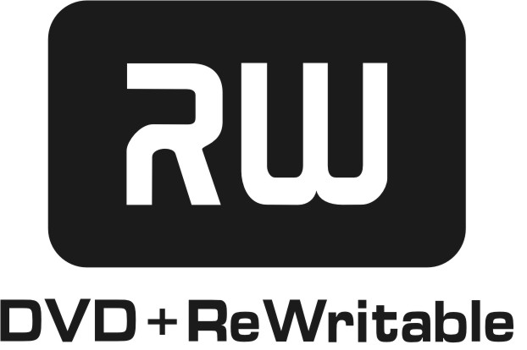


To ensure proper use of this product, please read this owner’s manual carefully and retain for future reference. Should the unit require maintenance, contact an authorized service location. Only qualified service personnel should remove the cover.

- WARNING: DO NOT EXPOSE THIS APPLIANCE TO RAIN OR MOISTURE, DUE TO THE HIGH RISK OF FIRE OR ELECTRIC SHOCK, DO NOT OPEN THE CABINET DANGEROUS HIGH VOLTAGES ARE PRESENT INSIDE THE ENCLOSURE . ONLY QUALIFIED SERVICE PERSONNEL SHOULD ATTEMPT THIS.
- CAUTION: TO PREVENT ELECTRIC SHOCK, MATCH WIDE BLADE OF PLUG TO WIDE SLOT, AND FULLY INSERT.
- ATTENTION: POUR EVITER LES CHOCS ELECTRIQUE, INTRODUIRE LALAME LAPLUS LARGE DE LA FICHE DANS LABORNE CORRESPONDANTE DE LAPRISE ET POUSSER JUSQU' AU FOUD.

CAUTION : This Digital Video Disc Player employs a Laser System. To prevent direct exposure to the laser beam, do not try to open the enclosure.
Visible laser radiation emits when open and interlocks are defeated.
Use of controls or adjustments or performance of procedures other than those specified herein may result in hazardous radiation exposure.
DO NOT STARE INTO BEAM !
TABLE OF CONTENT

1. INTRODUCTION 4
2. ILLUSTRATION 5
2.1 Rear Panel 5
2.2 Front Panel 6
3. SYSTEM SETUP 7
3.1 General Setup 8
3.2 Playback Settings 8
3.3 Record SETUP 9
3.4 Language SETUP 9
3.5Tuner SETUP 10
3.6 CLOCK SETUP 10
4. SOURCE MODE 11
5. DISC OPERATING MODE 12
6. EDITING 13
7. RECORDING MODE 15
7.1 Manual Recording 15
7.2 One Touch Recording (OTR) 16
7.3 Timer Recording 17
8．PLAYING BACK MODE 19
8.1 Playing a normal disc 19
8.2 Playing a DVD+R or DVD+RW disc 20
8.3 General Features 21
8.4 Locating a Specific Title, Chapter or Track 23
9. INSTALLATION 30
9.1 PLAYING BACK 30
9.2 RECORD FROM REAR PANEL 31
9.3 RECORD FROM FRONT PANEL 32
10. SPECIFICATIONS 33
11. TROUBLE SHOOTING GUIDE 34

1. INTRODUCTION
This DVR combines the functionalities of a DVD player and recorder. As a DVD player, you will be able to enjoy full length movies with true cinema picture quality, and stereo or multichannel sound (depending on the disc and your playback system). Unique features of this player include component video & S-video outputs, progressive scan for greater picture clarity.What’s more, as a DVD Video Recorder, it has some of the key features that allow you to record programs conveniently such as:
- A complete DVD+RW/DVD+R recorder
- Preset recording
- Record TV Programs
- Record from Digital Camcorder via IEEE1394 interface
- Playback of pre-recorded or user-recorded DVDs and CDs
- View, edit and play from a pre-recorded DVD+RW

2. ILLUSTRATION

2.1 Rear Panel
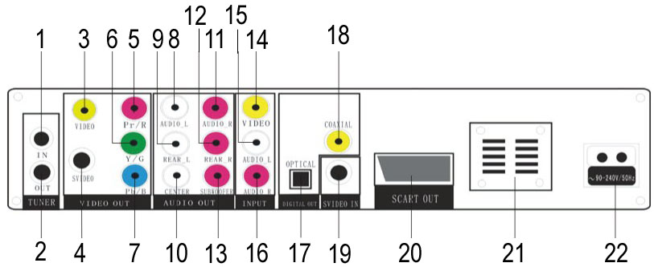
- TV TUNER input
- TV TUNER output
- COMPOSITE VIDEO output
- S-VIDEO output
- COMPONENT VIDEO output (Pr)
- COMPONENT VIDEO output (Y)
- COMPONENT VIDEO output (Pb)
8,9,10,11,12,13. 5.1CH AUDIO output
14. COMPOSITE VIDEO input
15. Left AUDIO input
16. Right AUDIO input
17. OPTICAL output
18. COAXIAL output
19. S-VIDEO input
20. SCART output
21. FAN
22. POWER input (AC 90 ~ 220V)

2.2 Front Panel
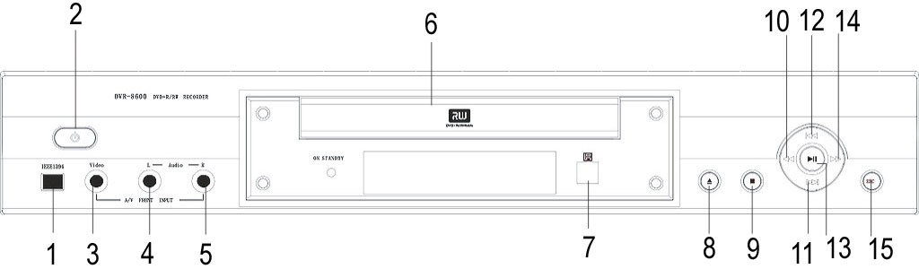
- IEEE1394 input
- STANDBY/ON button
- COMPOSITE VIDEO input
- Left AUDIO input
- Right AUDIO input
- DISC tray
- Infrared remote sensor
- OPEN/CLOSE button
- STOP button
- FAST BACK button
- NEXT button
- PREV button
- PLAY/PAUSE button 14. FAST FORWARD button 15. RECORD button

3. SYSTEM SETUP
This chapter describes how to set and adjust using the on-screen General Setup menu. Using the setup display, you can do the initial setup, select the picture quality for recording, scan TV channels and also other DVD playback parameters.

Note: The recorder should be at complete stop mode when doing the setup.

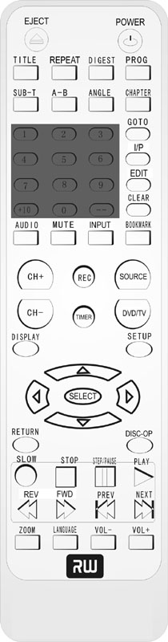
Press the SETUP button to enter the system setup mode. The screen displays the system setup control bar as shown in the following:

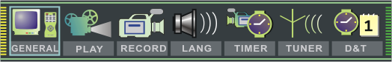
SETUP
Select the desired item by using <, > buttons, press the Up or Down arrow button to go to the setup submenu. Then press SELECT and there is a list of options to select. Go to the desired option by using Up/Down arrow button and press SELECT to confirm the setup.

SELECT
< ,> UP/DOWN

3.1 General Setup
- Screen saver
The Screen saver function is that a screen saver picture displays on screen automatically when there is no change on the recorder’s video output signal for a certain time.
Move the cursor up and down to select “ON” or “OFF”. Press SELECT to turn on or off the screen saver function.
- Progressive/Interlace
Progressive Scan creates a picture with double scan lines of traditional component video pictures and a sharper image.
Select “Progressive” or “Interlace” by pressing the SELECT button.
Press the I/P button on the Remote Controller can also proceed the Progressive/Interlace switch.
Note: If nothing is shown on screen, you may try to press the I/P button.
- Video Output
Select “YUV” or “RGB” in the list.
Select “YUV” when using the component video output.
- Video Output Format
This recorder has two video output systems: PAL and NTSC. You select according
to your TV set specification.
- Restore Factory Settings
You can restore the factory settings by using this option.
Highlight “OK” and press SELECT to confirm.

3.2 Playback Settings
- TV Aspect Ratio
On the list, you can select:
“16:9”- applicable to wide screen TV set
“Pan Scan”- suitable for the common size TV set. When playing wide screen pictures, left and right edges of the original pictures are cut off.
“Letter Box”- suitable for the common size TV set. When playing wide screen pictures, black banners will appear on the top and bottom of the TV set.
Note: The playback effect is related to the recorded pictures of the disc. Some discs may not be played back according to the screen setting you select.
- Rating Level
By setting the recorder’s authorization rating and password, some discs with control grade cannot be played without inputting the password. Therefore, you can restrict the persons to watch the discs.
Move the cursor to the Rating Level Setup, press Goto on Remote Control to SELECT the password. Or you can select “OFF” to ignore the setup.
- Digital Audio Output
The recorder has digital audio output jacks. You can either select “RAW” or “LPCM” according to what amplifier it is connected.
- Closed Captions
You can select “ON” or “OFF” and then press SELECT to confirm. This setup is only valid to the TV sets and discs that support the Captions function.

3.3 Record SETUP
- Auto Chapter Marker
This setup is used to make sure whether insert the chapter marker automatically during recording.
You can select “ON” or “OFF” and press SELECT button.
- Default Source
There are several types of input signal sources to be set as default.
- F-A/V Front panel composite audio and video input
- R-A/V Real panel composite audio and video input
- R-SV Real panel S-video input
- DV Front panel DV input
- TUNER Real panel TV turner input
- Default Quality
There are different levels of recording quality to be selected. They are:
SLP, EP, SP and HQ, with HQ is the highest quality and SLP is the lowest. The quality level will affect the maximum recording time of a disc. Normally, the recording time is SLP( 6 hours), EP (4 hours), SP (2 hours) and HQ (1 hour).

3.4 Language SETUP
- OSD Language
Select your desired language and press SELECT button to confirm and the OSD language will change accordingly.
- Menu Language
If you play the DVD discs that support the selected language, the recorder will adopt this language as the DVD menu language.
If the disc does not support the selected language, the recorder will use the language supported by the disc.
Select your desired language and press SELECT to confirm.
- Subtitle Language
Some DVD discs have many kinds of subtitle languages and this setup is used to set the default DVD subtitle language.
Select your desired language and press SELECT to confirm.
“OFF” means closing the subtitle output.
The recorder will select this setup language as the DVD subtitle language preferentially. If the DVD discs you select do not support this language, this setup is invalid.
- Audio Language
For some DVD discs when playing, it will display the language selection menu. If you prefer the selection in it, the corresponding setup of this recorder will be invalid, and the relative languages are the ones you select.
In case some DVD discs do not have the language you set, the setup will be invalid. When playing, the relative languages are the corresponding ones provided by the discs.
Select your desired language and press SELECT button.

3.5 Tuner SETUP
- Channel Scanning
Before receiving TV signals, you have to proceed channel scan operation to tune the recorder automatically to receive the TV programs. The result of the scanning will be saved and it will not be lost even the recorder is switched off.

In the system setup control bar, move to “TUNER” and press SELECT to SELECT the channel scanning submenu.
According to the connected input signal, select ‘Cable’ or ‘Air’ as the value of the input signal item. ‘Cable’ is the cable video signal and ‘Air’ is the antenna signal.
Select “SCAN” and press SELECT to start channel scanning.
- To receive TV programs, you only need to input the corresponding channel number
- When finishing the channel scanning, the cursor will go back to the left end of the progress bar.
- When finishing scanning a channel, if it found no TV signal, the Skip check box on the right of the channel number will be marked otherwise it will be un-marked.
- You can press Stop button to stop during scanning
- When scanning a channel, the TV screen will show the image of this channel’s signal.

If you want to skip a certain channel when receiving TV programs, you may mark
the corresponding skip check box of this channel by cursor button, and press SELECT
Pressing the SELECT button again can cancel the selection.

- Channel Fine Tuning
After finishing the channel scanning, some channels’ frequency may not be adjusted to right value. In this case, the image and sound will become misty. Then you can perform the channel find tuning to adjust these channels’ frequency.

- SELECT to the Tuner menu and select the Skip check-box correlative with the desired channel to be tuned in the column “Skip”. Then un-mark it by the SELECT button.
- Press the ‘<’ button to select the channel number in the column “CH”
- Press the Goto button, the Channel Edit menu will be shown on the TV screen.
- Fine tune the channel by repeatedly pressing ‘<’ or ‘>’ buttons. (‘>’ to increase the frequency, ‘<’ to decrease the frequency)
- When changing the frequency, you can see the effect of the find tuning.
After finishing the fine tuning, highlight the “Confirm: in the menu and press SELECT button to return to the Tuner menu.

3.6 CLOCK SETUP
- Date
Move the cursor to the Date (mm/dd/yy) bar and press Goto button to make it in
input mode. Use the number buttons to input the current date according to the
sequence of “month/date/year” and then press Goto to confirm.
- Time
Move the cursor to the Time (hh:mm:ss) and make it in input mode. Use the
number buttons to input the current time according to the sequence of “hour/
minute/second” and then press Goto to confirm.
- AM/PM
This setup is used to indicate the time at AM or PM.
Select “AM” or “PM” and press SELECT.

4. SOURCE MODE
At the Source mode, the recorder only displays the selected external signals on the TV. This mode is designed for selecting the recording source. You can preview the external signals at the Source mode.

Press the SOURCE button repeated and the input signals can be selected in the following sequence : Reading Disc mode > TV Input > F-A/V > R-A/V > R-SV > DV and then return to Reading Disc mode again.

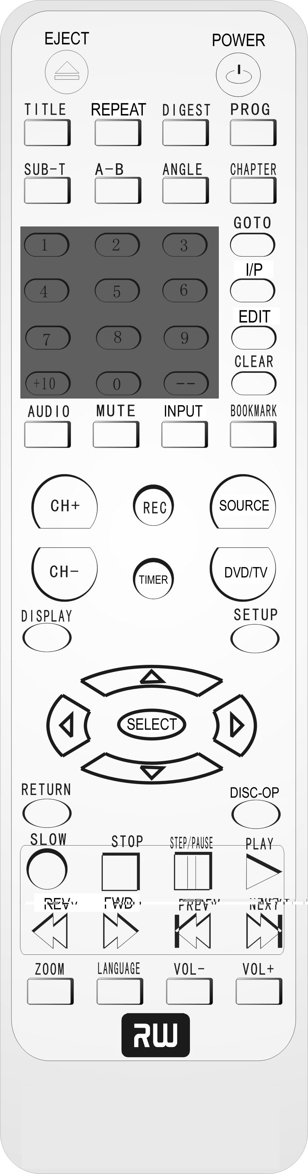
SOURCE
CH +/-
If the input source is TV signal, press CH+/- buttons to switch the TV channels.

Note: The recorder’s preset video format should be the same as the external source. Otherwise, it cannot detect the external source signals and then the recording cannot be processed.
Before receiving TV signals for the first time, perform the channel scanning operation. Refer to the System Setup for details.

5. DISC OPERATING MODE
This mode refers to some operations on the disc in the loader, ie: viewing the disc information, finalizing a disc, erasing the disc contents etc.

When the recorder is at stop mode with the disc (DVD+R or DVD+RW) inside the loader, press Disc-Op to select this mode.

DISC-OP
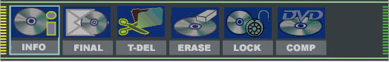
The control bar of this mode will be shown as follows:

- INFO: Show the disc information
- FINAL: To finalize a disc. This can make the DVD+R disc to be played in other normal DVD players. If finalized, the disc is impossible to record new contents or make any modification.
- T-DEL: To erase last title. You can erase the last recorded contents, this function is only available for DVD+RW disc.
- ERASE: This function is to erase all the disc contents. This function is for DVD+RW only.
- LOCK: This is to protect the recorded contents from being erased.
- COMP: To make compatible. This function can make the recorded DVD+RW disc able to be played back in the normal DVD players.

6. EDITING
The Editing function is set to perform chapter selection playback, random program playback, to change the index icon and name of each title etc.

When a DVD+RW disc is put inside the drive and the recorder is not in the status of writing or erasing the disc, press Edit button to enter the editing mode and the control bar will be shown.

- The Editing function is only available for DVD+RW disc.
- When “Invalid” appears when you press the EDIT button. It means the DVD+RW disc in the loader may have been write protected, or the current mode does not allow editing function. You can use the Disc Operation to cancel the write-protect or exit the current mode.

The Editing control bar is shown as follows:

EDIT
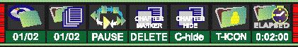
- View current title/total title
- View current chapter/total chapter
- Current operation status
- Chapter editing: select to add one chapter marker, or delete the current/all chapter markers.
- Chapter hide or unhide: select to hide the current chapter
- Title Icon or Title name: select to set the current image played back to the face of the title (index picture) or select to name the current title
- Timer: time elapsed of current title

Operating Steps:

- Select the title to be Edited
Select the Title selection item by using < or > button in the editing control bar.
Press Goto button to go to the input mode.
Input the number of the title to be edited by using the number buttons, then press
Goto button and the recorder will start repeatedly playing this title.

- Chapter Editing
In the Editing control bar, select the Chapter Editing item and press Goto to make the input mode.
Select the proper value by using up/down buttons and press Goto button to confirm, then the system will start separating or combing the current chapter.
- “Delete”- this chapter and the previous chapter will be combined to one chapter
- “New”- this chapter will be separated into two at the current location
- “Del-All”- all chapters of this title will be combined into one chapter.

- Chapter hide or unhide
In the Editing control bar, select the Chapter hide/unhide item and press Goto button to select the value.
- “C-hide”- this chapter will be skipped when playing in normal mode
- “C-unhide”- this chapter will be played when playing in normal mode

- Title Icon or Title name
  - Changing the Title Icon
In the Editing control bar, select the T-Icon by using up/down button. When meeting the favorite picture to be the Title Icon (index picture), press Goto button and this picture will become the index icon of the title.
- Changing the Title Name
In the Editing control bar, select the T-Name by using up/down button. Press Goto button to display the Title Name Editing menu.
You can type a new title name by using the keys inside character area.
Select the OK key and press the button to confirm the Title Name.

Press EDIT button to exit the Editing menu and the recorder will write the information into the disc, the unit will stop responding for a while when updating.

7. RECORDING MODE
The recording discs of the recorders are DVD+RW and DVD+R. There are four levels of recording quality to be selected, including SLP (6 hours), EP (4 hours), SP (2 hours), and HQ (1 hour).

The unit also incorporates One-touch recording function and Time recording function which gives you more choices and greater flexibility to record your desired programs.

7.1 Manual Recording
General steps of recording external signals are as follows:
- Connect the recorder
- Turn on the recorder and load the DVD+R/RW disc
- Press SOURCE button to select the desired source to be recorded. (The input source must match with the actual connecting terminal so you can view the input source signals on TV)
- Press REC button to start recording
- Press STOP button to stop recording

SOURCE
REC
STOP

At Source mode, you can also enter the Recording Control Menu bar by pressing DISC-OP button two times. The bar will appear as follows:

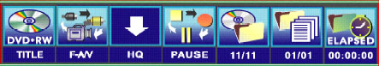

- Disc Type: It must be DVD+RW or DVD+R
- Record Input Source
  - F-A/V: Front Audio/Video input
  - R-A/V: Rear Audio/Video input
  - R-SV: Rear S-Video Input
  - DV: Front Digital Video input (1394 interface)
  - Each channel ( you can select it by pressing CH+/- or input the assigned number of the channel to select your desired one directly)
- Recording Quality
- HQ High Quality, nearly 64 minutes in a blank disc
- SP Standard Play, nearly 130 minutes in a blank disc
- EP Extend Play, nearly 250 minutes in a blank disc
- SLP Standard Long Play, nearly 366 minutes in a blank disc
- Recording Process Control
- The number of the recorded titles
- The number of the recorded chapters
- The remaining recordable time of the disc

In the recording control menu bar, select the desired item through <, > buttons and press Goto button to make it in input mode. Select the desired options through UP/DOWN buttons and press SELECT to confirm.

7.2 One Touch Recording (OTR)
This function allows you to set the end time of the recording during the normal recording. When the time is up, the recorder will stop recording automatically.

Steps of One Touch Recording:
- Enter the recording mode and start normal recording
- According to the desired time, press REC button once or more. the record time will extend for another 30 minutes with each press of REC button
  - the length of recording time is determined by disc capacity and record quality.
  - With your setting, if it will exceed the capacity of the disc, OTR will be canceled and switched to normal recording
- If the OTR process is paused or stopped, the recorder will cancel the OTR.

7.3 Timer Recording
This function can make the recorder start recording automatically according to the preset requirements when the preset-time is coming. It will resume the original mode after finish recording. Before set the record schedule, first set up the clock of the recording according to Clock Setup section Steps in setting the Record Schedule:

- Press the TIMER button to display the record scheduler menu shown as below:

TIMER
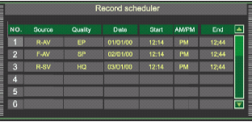
CLEAR

- Select one of the schedules in the record scheduler menu through UP/DOWN buttons. Then press SELECT button to the Item Editor menu.In each item you can use the direction keys to highlight and press SELECT to choose your desired setting:

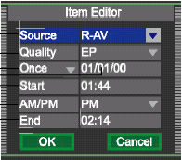

Signal input source
Record quality
Record frequency, once, daily or weekly
mm/dd/yy
Start time for timer recording
AM/PM selection
End time for timer recording

Select ‘Confirm’ to save your setting.
Press TIMER button to exit the record schedule menu.

Note:
- After finish setting, make the recorder in standby or working mode,
- You can cancel a schedule by pressing CLEAR button
- In five minutes before it is ready to record the scheduled, it appears a Record Prompt dialog, to affirm press OK, to cancel press Cancel, and without operation for a moment it will record the scheduled automatically.
- In standby mode, the recorder will wake up in 2 minutes before recording
- During recording, you can suspend the recording by pressing Stop
- After the recording is finished, the recorder automatically enters the original mode

8．PLAYING BACK MODE

8.1 Playing a normal disc
- Power on your recorder.
- Insert a DVD disc.
- Press Direction keys or the number buttons to select the title.
- Press the SELECT or PLAY button.
The DVD video player will start playback from the title selected.
- To remove the disc, press the EJECT button.

PLAY
SELECT
EJECT
STOP

8.2 Playing a DVD+R or DVD+RW disc
- Power on your recorder.
- Insert a DVD+RW or DVD+R disc.
The index pictures will appear on the screen
- Press the EJECT button
This will open the disc tray and allow for the placement of a playable disc
with the playback side down.
- Use direction keys (UP/DOWN/RIGHT/LEFT) to
highlight the item you desired.
- Press SELECT or PLAY to start playback of the titleyou selected.
When PREV is highlighted, press SELECT, the previous index pictures will
display on the screen. When it reaches the first one, if press PREV again,
the Index Picture Screen can only be updated.
When NEXT is highlighted, press SELECT, the next index pictures will
display on the screen. When it reaches the last one, if press NEXT again,
the Index Picture Screen can only be updated.
- Stop playback
Press the STOP button once to stop the player; press the PLAY button to
resume playing.To playback from the start, press the STOP button twice then press the
PLAY button.

Note:
After finishing playback of all titles contained on a DVD+RW or DVD+R
disc, it will return to the Index Picture Screen.

8.3 General Features
All playback operation can be realized by the DISPLAY.
During playback, press DISPLAY to access the control bar:

DISPLAY
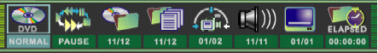
Control bar is a collection of icons. Those icons are presentations of commands or information that needed to finisha function. The details of every functions see below:

Press RIGHT/LEFT to highlight one icon and press SELECT to enter it, press UP/DOWN to select a item,press SELECT.
Press DISPLAY again to cancel the control bar.
SLOW
FWD
REV
STEP/PAUSE

- Playback mode Set your preferable playback mode such as PROGRAM,RANDOM and various repeat mode.
- Playback control Control playback by various setting such as FAST,FORWARD, FAST REVERSE, PAUSE,STOP, etc.
- Title Select to choose an available title by inputting numbers.
- Chapter Select to choose an available chapter by inputting numbers.
- Angle Select your desired camera angle, if available.
- Audio Select your desired audio setting, if available.
- Subtitle Select to choose an available subtitle by inputting numbers.
- Timer Goto the point you want to start from by inputting the time.

Also,you can implement the Playback control by Remote:
- Fast forward playback
Press FWD during normal playback.
The speed will cycle with each press as: FF2, FF4, FF16, FF32 or play.
Press PLAY to resume normal playback.
- Fast reverse playback
Press REV during normal playback.
The speed will cycle with each press as: FR2, FR4, FR16, FR32 or play.
Press PLAY to resume normal playback.
- Pause playback
Press STEP/PAUSE, during normal playback to pause playback and
press PLAY to resume normal playback.
- Frame advance
Press STEP/PAUSE during normal playback.
One frame is advanced each time you press STEP/PAUSE.
Press PLAY to resume normal playback.
- Slow
Press the SLOW button during playback
The playback speed becomes 1/2, 1/4, 1/8 of the normal speed or
normal play each time you press the SLOW button.

Note:
The above features vary depending on the disc type such as MP3, Audio CD, DVD+RW/DVD+R etc.

8.4 Locating a Specific Title, Chapter or Track
DVD VIDEO DISCS ARE NORMALLY DIVIDED INTO TITLES AND SUB-DIVIDED INTO CHAPTERS.SIMILARLY, CD’S (AUDIO, HDCD, and MP3) ARE DIVIDED INTO TRACKS. YOU CAN CONVENIENTLY LOCATE ANY SPECIFIC TITLE, CHAPTER, OR TRACK WITH THIS DVD PLAYER.

NEXT
PREV
TITLE
GOTO
REPEAT

8.4.1 LOCATING A TITLE USING THE TITLE MENU

You can locate a specific title using the title menu function, if a DVD video disc contains a title menu.
- Press the TITLE button On the TV screen, the title menu will appear.
- Press the Direction button to select the title you want
- Press the SELECT button .This will cause the DVD video player to start playback from chapter 1 of the title selected .
NOTICE:
• There are some disc that does not respond to this function.
• If different instructions appear on the TV screen, follow those instructions. The instructions above are describe the basic procedure, but procedures may vary depending on the contents of the DVD video disc.

8.4.2 LOCATING A SPECIFIC CHAPTER OR TRACK

This player allows you to locate consecutive chapters or tracks.
Press the PREV or NEXT button repeatedly to display the requested chapter or track .The player starts playback from the selected chapter or track.
How to locate proceeding chapters or tracks
• When you press the PREV or NEXT button, the player starts playback from the beginning of the
preceding chapter or track.
How to locate succeeding chapters or tracks
• When you press the PREV or NEXT button, the player starts playback from the beginning of the
succeeding chapter or track.

NOTICE:
On some discs the titles may not display the sub-divided chapters.

8.4.3 LOCATING A TITLE

If a DVD video disc contains title numbers, you can locate a specific title by directly selecting a title number.

- Press GOTO during playback.
The control bar will display on the screen.

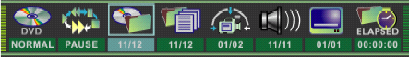

- With the TITLE icon highlighted, input the number of a vailable title,
then press SELECT to confirm it.
- To select your desired chapter, press GOTO to highlight the icon ,
and input the number of a vailable chapter, then press SELECT.
- If you want to start playback from some point, press GOTO to highlight the icon , and
input the time, then press SELECT.

NOTICE:
• The function is invalid on MP3 disc.
• For CD disc, GOTO is used for track/ time selection.
• For DVD+RW/+R, it cannot function by time searching.

8.4.4 Playing Repeatedly

THIS RECORDER ALLOWS YOU TO PLAYBACK A SPECIFIC TITLE, CHAPTER, TRACK, OR SEGMENT REPEATEDLY. (TITLE REPEAT, CHAPTER/TRACK REPEAT, A-B REPEAT)

HOW TO REPEAT A TITLE, CHAPTER, OR TRACK

Press the REPEAT button during playback.
The repeat mode changes, each time you press the REPEAT button.

Repeats the same chapter.
Repeats the same title.
Repeat the whole disc.
Resumes normal playback.

HOW TO REPEAT A SPECIFIC SEGMENT

- Press DISPLAY to access the control bar.
- Highlight Playback mode by pressing RIGHT/LEFT, press SELECT.
- Use UP/DOWN to select A-B and press SELECT at the beginning of the segment in which you want to repeat playback (point A).
- Press SELECT again at the end of the segment (point B)The player will automatically return to point A and start to repeat playback of the selected segment (A-B).
- Highlight Playback mode by pressing RIGHT/LEFT, press SELECT.Use UP/DOWN to select NORMAL and press SELECT to resume normal playback.

NOTICE:
• There are two repeat modes for MP3/CD disc. On CD disc, they are track repeat and disc repeat,
and on MP3 disc, they are repeat song and repeat directory.

8.4.5 Playing in Random Order

- Press DISPLAY to access the control bar.
- Highlight Playback mode by pressing RIGHT/LEFT, press SELECT.
- Select RANDOM mode.

NOTICE:
• The player will go to another chapter or track and start playback, if you press the PREV or NEXT button , during random playback.
• When MP3/CD disc is played back, the display icon is different from each other.

8.4.6 Selecting Camera Angles, Languages & Audio Settings

THIS RECORDER ALLOWS YOU TO SELECT FROM SEVERAL DIFFERENT ANGLES AND LANGUAGES.

ANGLE
AUDIO
HOW TO CHANGE THE CAMERA ANGLE

If the video on the DVD was recorded with multiple angles, you have the
option to change the camera angle of the scene you are watching.
Press the ANGLE button while playing back a scene recorded with multiple angles.
• You may only press the ANGLE button when the angle icon is shown on the DVD display.
• Each time you press the ANGLE button, the angle will change.

NOTICE:
• The angle function will not work on DVD video discs that does not contains recorded multiple angles.
• During still playback, you are able to change the camera angle. When you resume to normal playback, the camera angle changes to the new settings.
• The angle icon indicator will illuminate while playing back a title that contains at least one scene recorded from multiple angles.

HOW TO SELECT A LANGUAGE & PLAYBACK AUDIO SETTING
This player allows you to select a preferred language and sound recording system from those
included on the DVD video disc.
1. Press the AUDIO button during playback
2. Press the AUDIO button repeatedly to cycle through the options
NOTICE:
• The player returns to the initial default settings when you turn on the player or replace a disc.
• The player plays a default sound when unsupported format is selected.
• On MP3/CD disc, AUDIO is used for the selection of LEFT, RIGHTand STEREO.

8.4.7 Playing in a Favorite Order

THIS PLAYER ALLOWS YOU TO PROGRAM UP TO 99 ITEMS INTO MEMORY AND THEN PLAY THEM BACK IN THAT ORDER. (PROGRAM/PLAYBACK)

HOW TO SET TITLES, CHAPTERS, OR TRACKS IN A FAVORITE ORDER

- Press DISPLAY to access the control bar.
- Highlight by pressing RIGHT/LEFT, press SELECT.
- Use UP/DOWN to select PROG and press SELECT, two volumes will appear on the screen.

PROG
• The left volume displays all titles available on the disc.
• The right volume allows you to edit titles in your favorite order.

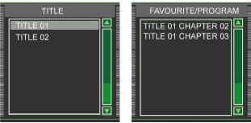
- In the left volume, use UP/DOWN to select one title, and press ADD/CLEAR to add it to the right volume.You can also select one chapter by pressing SELECT after highlighting the title.
- To clear one title you have added in the right volume, highlight the one and then press ADD/CLEAR to clear it. Use RIGHT/LEFT to move the cursor between the volumes.
- Press RETURN to return the control bar. Select Playback mode , use UP/DOWN to select NORMAL and press SELECT to resume normal playback.

NOTICE:
• On the MP3/CD disc, there are some difference on OSD.

CLEAR

8.4.8 Selecting Subtitles

THIS RECORDER ALLOWS YOU TO DISPLAY THE SUBTITLES FROM THOSE INCLUDED ON THE DISC ON TO YOUR TV SCREEN.

SUB-T
Press the SUB-T button during playback to choose one of the subtitle available on the disc, or turn the subtitle off.

NOTICE:
• Due to the nature of some DVD’s, you may not be able to turn off the subtitles as they will appear on screen automatically.
• As you press the SUB-Tbutton, the subtitles may not appear immediately during some scenes.
• If the subtitles continue to show on your TV even after the DVD has been turned off, please check the closed caption settings on your TV.
8.4.9 Setting the Parental Lock

YOU CAN USE THE PARENTAL LOCK FUNCTION ONLY WITH DVD’S EQUIPPED WITH THE PARENTAL LOCK FEATURE

SETTING THE PARENTAL LOCK
DVD equipped with the parental lock function are rated according to their content. The contents allowed by a parental lock level and the way a DVD can be controlled may vary from disc to disc. For example, if the disc allows it, you could edit out violent scenes unsuitable for children and replace them with more suitable scenes, or lock out playback of the disc all together.

- Press STOP button twice during playback.
- Press SETUP during stop status.
- Highlight the PLAY icon by pressing RIGHT/LEFT.
The menu appears on the TV screen.

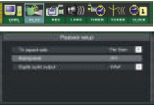

- Use UP/DOWN to select Rating Level, press SELECT button.
- Input your password by numbers, highlight OK and press SELECT. The pre-set password is 3308
- Press SELECT , the sub-menu of Set Rating Level appears, use UP/DOWN to select one rating,press SELECT to confirm it.

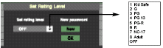

- Highlight OK and press SELECT to save your setting.
- Press SETUP button to exit setup, press PLAY button to start

TO CHANGE YOUR PASSWORD:
  - Follow step 1-6 to select “New”.
  - Enter new password.
  - Re-enter to confirm your new password.
  - Highlight OK and press SELECT to save it.
  - Press SETUP button to exit.

9. INSTALLATION

9.1 PLAYING BACK
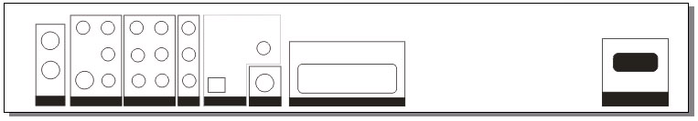
VIDEO
Cable TV
SOCKET
AUDIO L/R
SCART
TV
POWER
AC 90-240/50Hz

9.2 RECORD FROM REAR PANEL

VIDEO
AUDIO L/R
DVD PLAYER

9.3 RECORD FROM FRONT PANEL

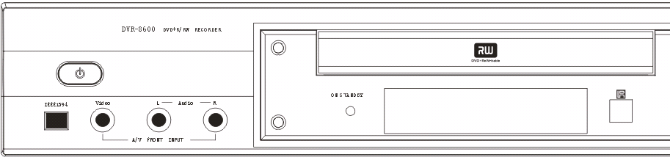
1394

VIDEO
AUDIO L/R
DVD PLAYER

10. SPECIFICATIONS
DVD RECORDER
Power supply | 90 – 220V AC / 50Hz
Power consumption | 38W
Mass | 4.4Kg
Signal system | NTSC/PAL
Laser | Semiconductor laser, wavelength 650 nm

SUPPLIED ACCESSORIES
Audio cable (red and white) | 1
Remote control | 1
Batteries (AAA) | 2
Video cable | 1
AUDIO cable | 1
Owner’s manual | 1

NOTICE:
Design and specifications are subject to change without notice.

11. TROUBLE SHOOTING GUIDE
Symptom | Correction
No power | • Connect the power plug into the wall outlet securely.
No picture | • Verify the connection from the DVD video output to the TV video input. Then switch TV to appropriate mode (video 1)  • Connect the video cable into the jacks securely. Refer to your television owners manual.
No sound | • Connect the audio cables into the jacks securely.  • Verify the connection from the DVD audio output to the TV or receiver audio input. Then switch to the appropriate source on the receiver. Refer to your audio amplifier owners manual.
Black & White  picture | • Damaged S connector (bent pin)
The playback  picture has  occasional distortion | •A small amount of picture distortion may appear because of a poor quality video/sound transfer to disc. This is especially true of some discs manufactured between 1997-1998..  • Scratched disc
Brightness is unstable or noises are produced on  playback pictures | • Connect the DVD player directly through the TV and not through any other source. What you’re viewing is the effect of the copy protection circuitry required on all DVD players.
The DVD video player does not start playback | • Place the disc with the graphics side up.  • Place the disc on the disc tray correctly inside the guide.  • Make sure the disc is free from scratches & fingerprints.  • Press the SETUPbutton to turn off the menu screen.  • Cancel the parental lock function or change the parental lock level. (The Pre-set password is 3308.)  •Turn the power off then disconnect the power plug and reinsert it back into the wall. Retry again.  • Use region 1 discs only.
MP3 won’t read disc or it skips | • Reburn disc as the software edition used may not be compatible with the player. Check web site for instruction.  • Use new editions of software such as Voyetra Audiostation 4, Adaptec’s “Easy CD Creator”, NTI or Roxio’sToast Titanium.  • Make sure MP3 file are not encoded with a variable bit rate such as provided by Real Networks.
The remote control does not work properly | • Replace the batteries with new ones.
The recorder cannot record. | • The type of the disc is wrong, it’s not a DVD+RW or DVD+R disc.  • The disc is recorded full.  • The disc (DVD+R, DVD+RW) is locked, it should be unlocked.  • The DVD+R has been finilized.
Some keys do not work | • The type of the disc is wrong, it’s not a DVD+RW or DVD+R disc. The unit is in record mode or it is recording.
The image is distorted. | • The setup of Interlaced or Progressive is wrong.  Press the I/Pbutton to switch from each other.

