TM0080  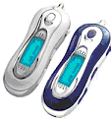 | 1.Neckline Earphone  2. User’s Manual  3. 1 AAA Battery  4. Driver CD  5. mini usb cable | MP3 +USB drive + Voice Recorder  - Format: MP3/WMA  - Voice recorder: ACT format  - A-B repeat, Repeat One, Repeat All, Normal  - FM Radio ( Option )  - 7-mode equalizer: Jazz, Classic, Rock, Pop, Normal, Soft, DBB  - Support ID3 function.  - LCD: 96 x 26 dot matrix + blue EL backlight  - Lyrics display  - Eight Languages display: German, Spanish, French, Italian, Swedish, Czech, English and Chinese  - Language Learning Recorder  - Weight: 29g  - Size: 83mm*32mm*21mm
TM0080B  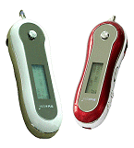 | 1.Neckline Earphone  2. User’s Manual  3. 1 AAA Battery  4. Driver CD  5. mini usb cable | MP3 +USB drive + Voice Recorder  - Format: MP3/WMA  - Voice recorder: ACT format  - A-B repeat, Repeat One, Repeat All, Normal  - FM Radio ( Option )  - 7-mode equalizer: Jazz, Classic, Rock, Pop, Normal, Soft, DBB  - Support ID3 function.  - Naometer LCD display  - LCD: 96 x 26 dot matrix + blue EL backlight  - Lyrics display  - Eight Languages display: German, Spanish, French, Italian, Swedish, Czech, English and Chinese  - Language Learning Recorder  - Weight: 29g  - Size: 83mm*32mm*21mm
TM0110  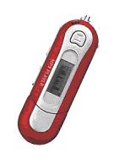  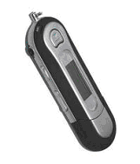 | 1. Neckline Earphone  2. User’s Manual  3. 1 AAA Battery  4. Driver CD  5. Usb Cable | MP3 +USB drive + Voice Recorder  - Memory: 32/64/128/256 MB  - Format: MP3/WMA  - Voice recorder: ACT format  - A-B repeat, Repeat One, Repeat All, Normal  - FM Radio (option)  - 7-mode equalizer: Jazz, Classic, Rock, Pop, Normal, Soft, DBB  - Support ID3 function  - LCD: 96 x 26 dot matrix + blue EL backlight  - Lyrics display  - Language Learning Recorder  - Weight: 36g(w/o battery)  - Size: 95*30*22mm
TM0110B  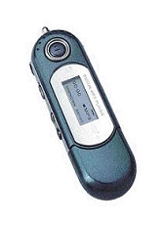  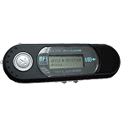 | 1. Neckline Earphone  2. User’s Manual  3. 1 AAA Battery  4. Driver CD  5. Usb Cable | MP3 +USB drive + Voice Recorder  - Memory: 32/64/128/256 MB  - Format: MP3/WMA  - Voice recorder: ACT format  - A-B repeat, Repeat One, Repeat All, Normal  - FM Radio (option)  - 7-mode equalizer: Jazz, Classic, Rock, Pop, Normal, Soft, DBB  - ID3 Tag  - LCD: 96 x 26 dot matrix + blue EL backlight  - 8 languages display: Chinese, English, French, Italian, Czech, German, Spanish, Swedish  - Lyrics display  - Language Learning Recorder  - Weight: 34g (w/o battery)  - Size: 90*29*21mm
TM0130  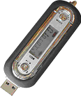  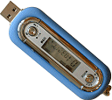  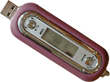 | 1. Neckline Earphone  2. User’s Manual  3. Driver CD  4. Usb Cabel  5 AC Adapter | MP3 +USB drive + Voice Recorder  - Memory: 32/64/128/256 MB  - Format: MP3/WMA  - Voice recorder: ADPCM  - A-B repeat, Repeat One, Repeat All, Normal  - FM Radio (option )  - 7-mode equalizer: ( Normal, Jazz, Classic, DISC, POP, DBB, Rock)  - LCD: 128*32 dot-matrix+ blue EL Blue backlight  - Lyrics display  - Language Learning Recorder  - Built – in Rechargeable battery  - Weight: 45.5g  - Size: 80.5mm*29,5mm*16mm
TM0150  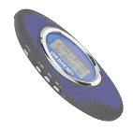 | 1. Neckline Earphone  2. User’s Manual  3. Driver CD  4. Usb Cabel | - Memory: 128/256/512MB  - Format: MP3  - Digital Voice recorder ADPM format  - A-B repeat, Repeat One, Repeat All, Normal, easy to learn foreign language  - Built in FM radio  - Lock up function: protection data and prevent the mistake action  - 6-mode equalizer: (Bass/Rock/Jazz/Classic/Pop/Flat  - LCD: 96 x 26 dot matrix + blue EL backlight  - Lyrics display, Traditional Chinese, Simple Chinese and English
TM0160  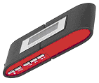  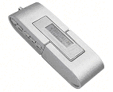 | 1. Neckline Earphone  2. User’s Manual  3. Driver CD  4. Usb Cabel | - Memory: 128/256/512MB  - Format: MP3  - Digital Voice recorder ADPM format  - A-B repeat, Repeat One, Repeat All, Normal, easy to learn foreign language  - Built in FM radio  - Lock up function: protection data and prevent the mistake action  - 6-mode equalizer: (Bass/Rock/Jazz/Classic/Pop/Flat  - LCD: 96 x 26 dot matrix + blue EL backlight  - Lyrics display, Traditional Chinese, Simple Chinese and English
TM0166  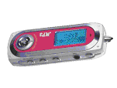 | 1. Neckline Earphone  2. User’s Manual  3. Driver CD  4. Usb Cabel  5. 1*AAA battery | - Memory:128/256MB  - Format: WMA/MP3  - Digital Voice recorder ADPM format  - 72hrs voice recording for 256mb  - A-B repeat, Repeat One, Repeat All, Normal  - 7-mode equalizer: ( Normal, Jazz, Classic, DISC, POP, DBB, Rock)  - LCD: 128*32 dot matrix + blue EL backlight  - ID3 Tag Lyrics display English , Traditional Chinese, Simple Chinese :  - Language Learning Recorder  - Automatically – shut - off setting
TM290B  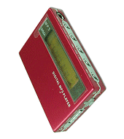 | 1. Neckline Earphone  2. User’s Manual  3. Driver CD  4. Usb Cabel  5. DC Charger | MP3 +USB drive + Voice Recorder ---- color: silver, blue and red  - Memory: 32/64/128/256 MB  - Format: MP3/WMA  - Voice recorder: ACT format  - A-B repeat, Repeat One, Repeat All, Normal  - FM Radio (option)  - 7-mode equalizer: Jazz, Classic, Rock, Pop, Normal, Soft, DBB  - Support ID3 function  - LCD: 96 x 26 dot matrix + blue EL backlight  - Lyrics display  - Built – in Ni-mh Battery can be recharged by USB Port or Charger  - Language Learning Recorder  - Weight: 29g(w/o battery)  - Size: 57*37*11mm
TM308  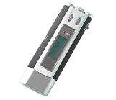 | 1. Neckline Earphone  2. User’s Manual  3. Driver CD  4. Usb Cabel  5. 1*AAA battery | MP3 +USB drive + Voice Recorder  - Memory: 128/256 MB  - Format： MP3  - Voice recorder: 5hrs for 64MB  - 5-Mode Repeat  - FM Radio ( Option )  - 7-mode equalizer: Jazz, Classic, Rock, Pop, Normal, Soft, DBB  - EL Blue back light  - English /Chinese display  - Weight: 34.1g  - Size: 98.7*31.2*17.4MM

